CSC 3150 – Systems Design
System Proposal
Template and Instructions

This template document contains a general outline with comprehensive details on the CSC 3150 System Proposal.
Part 1 will include the red bold-underlined sections.
The green reverse-formatted sections are for Part 2.
You might find it helpful to fill in the sections by replacing the prompts of this outline/template as you go. It is OK to submit Part 1 with the green prompts in place. Then, replace those with your additional information for Part 2. Part 2 should have none of this template's prompts in it.
YOUR AUDIENCE for this document is varied.
Your primary purpose is to communicate your understanding of the proposed system to your client (and other stakeholders). However, this document also introduces the project to developers working on or joining the project. Finally, creating this System Proposal helps your developer team solidify their understanding of the system to be built and document this understanding.
The System Proposal needs to be written in a way that non-technical types can understand so they can read it and determine if your analysis 1) makes sense and 2) matches what they believe they want and need. Assume all readers are busy and want to quickly and efficiently find the information they seek.
Example readers include:
- Wanderer's Tools, especially those involved in financing ideas and those interested enough in computing technology to want to have input into the process
- End-users (if she is wise, the Product Owner has contacted a few representative potential users to see if this system might appeal to them)
- Your organization's dev team

Note: document sections are numbered (except for the Executive Summary). Subsection numbering (e.g., 1.0, 1.1, 1.2, 1.3) is optional. Be consistent throughout the document and match the (auto-generated) Table of Contents numbering.

Advice: Give your proposed system a "Code Name". Constantly referring to your product as "The proposed travel journal for Wanderer's Tools" for the entire document is tiring for you and your reader. An acronym is nice but not required. You can also give your product or developer group a code name. You aren't "stuck" with that name, and it can be changed in the future.

Detailed Instructions
(section by section)
Cover Page
Include all the required information and a visually interesting image for your product.

Table of Contents
[Automatically generated, as shown in class.]

Executive Summary
While the Executive Summary is the first thing your reader sees, wait and write it AFTER you have written the rest of the doc. DO NOT FORGET to add this to Part 2! It's a critical part of the document.

Analyze the Executive Summary sections of previous years' project proposal examples: what would be equivalent information for this project? You can put this on a separate page. Readers probably appreciate that, but it can also go above the Introduction and Overview if short. While the content may be like the Introduction and Overview, this is the official BRIEF introduction of yourself, your client, and the project.

1.0 Introduction and Overview
Section 1.0 should be approximately 3-5 pages long (single-spaced), even with many subsections. Words like "summary" and "brief" should guide your writing style.
Note the flow of the subsections below. First comes a statement of the problem, need, or opportunity that motivated the PIR (Project Initiation Request). Next is a brief description of what to build and why. The section concludes with your recommendations for the next steps in the project.
Sections that list items (Business Requirements, Stakeholders and Interests, Constraints) need at least a one-sentence introduction ("mini abstract") so the reader knows what the list is about.

Problem Statement
To determine the content of this 1—2 paragraph section, consider the following questions: Who is the customer, and why have they hired us? What is the need, problem, or opportunity being presented? Why are we going to build this? The input for this section is from the PIR's Opportunity Statement and Background and Context sections.

Project Vision and Scope
This section should capture the initial vision and scope of the proposed system. Take your client's PIR information and craft a vision statement based on the Opportunity Statement, Initial Vision, and Expected Benefits sections. 1—3 sentences should be enough. Then, briefly describe what you plan to build in response to this vision, including scope, boundaries, and environment. The Expected Costs and Benefits section should deal more with Benefits, focusing mainly on opportunity and vision.

Requirements Summary
Based on the client's PIR (see Initial Vision and Scope) and any other information you can glean from interviews, surveys, and research - what are the primary business requirements for this system? State these in 1 (or 2 max) sentences each. Hint: Bulleted lists work well here. Try to make this as complete as possible since readers should eventually trace these requirements to the more specific functional (and non-functional) requirements of Section 3.

Stakeholders and Their Interests
List the primary stakeholders and their interest(s) in the outcome of this development process. Again, the PIR is your starting point. But it is probably not a complete list of all interested parties. As the analyst, you may need to think beyond the usual stakeholders to create a complete list. Do not forget that you and the developers should hold the stakeholders accountable for clarifying the product's goals and requirements when needed.

Expected Costs and Benefits
This section is not included in all the sample examples, but you must include it. Since you are not doing an Economic Feasibility analysis (see Feasibility Analysis Module Materials), this is your one chance to address costs and benefits (albeit superficially). Include two subsections, one for the business benefits (mainly intangible) you expect the system to produce and one for listing the cost areas. Please note that there should be no monetary value for intangible benefits. If you can estimate a numerical economic value, then it's a tangible benefit. You may find inputs to this section in the PIR's Expected Benefits and Special Issues sections, but you will also "discover" some as you analyze the request and design of your product.

Constraints
List a summary of the software's constraints and limitations. These may include others already identified by you as developers. For each one, please describe how you expect it to affect the development process or product, how you plan to deal with it, and any potential limitations that may result. Only listing problems scares most clients, so being able to say, "But we can mitigate this risk by doing X," is an excellent idea.

Recommendation
What do you want your reader to do upon receipt of this document? Wanderer's Tools is your primary decision-maker; what actions should they take after reading your proposal? What "next steps" should now be taken? DO NOT FORGET to add this to Part 2!

Document Overview
Describe the organization and content of the rest of the System Proposal.
Be sure this needs to be updated for the Part 2 submission to include the entire document.

2.0 System Initiation
Include copies of the document that began this process – The PIR. No introduction or other text is needed.

Project Initiation Request (PIR)
A copy of the original Project Initiation Request (PIR) that was approved.

Reply Letter
A copy of your reply letter. [This was not assigned this quarter.]

3.0 Feasibility Assessment
The attached example (at the end of this document) shows one layout and the level of required detail. However, your sections should be different (remember that we added some feasibility sections), AND the complete assessment is not intended to fit on a single page.

Introduction
Tell the reader what this section is and covers. Describe the rating scale you use in the Feasibility Analysis that follows.

Feasibility Analysis
Include complete analysis for five areas of Feasibility - Technical, Resource, Schedule, Organizational, Legal, and Contractual. Each should at least get a brief paragraph; some require further analysis and discussion. Here are some essential things to keep in mind:
Pay particular attention to the questions asked about Technical Feasibility.
Remember that we are pulling out Resource and Schedule feasibility into separate sections.
Organizational Feasibility needs to consider all stakeholders specifically, and you need to consider both legal and business contractual issues.
Also, recall that Feasibility and risk are related: any risks you define lower Feasibility, and you require some statement of how you plan to overcome (mitigate) the risk!
WITH EACH FEASIBILITY TYPE, include a one or two-word rating of Feasibility or risk. This rating needs to be very visible to the reader.
NOTE: We are NOT doing economic Feasibility this quarter. You may see this in sample book documents, but DO NOT include it in your analysis.

Additional Comments
Put whatever is appropriate here.

Conclusion
What is the Feasibility of this project? What reservations (if any) do you have? What suggestions do you have for managing risks? Be sure to update this Conclusion section, if needed, for Part 2 based on anything you have learned since submitting Part 1.

4.0 Requirements Definition
Provide a text overview of system features, services, and behavioral properties. It has a combined audience, including technical (developer) and non-technical (user/client) readers.

Introduction
Tell the reader what this section is and what it covers. Not everyone reading this knows what "Functional and Non-Functional requirements" mean, so define these terms. However, do not sound like a textbook or quote class notes verbatim. Consider your reader!

Functional Requirements
Include a written overview of the system's functional requirements. The requirements should be organized logically (so that the system makes sense to the reader and they can determine if all services are included). The preferred format would be a bulleted or numbered list of requirements. Each requirement should be given a "name" (highlight this somehow) and a 1 or 2-sentence description. This number and name are critical when you refer to and cross-reference these requirements with the Use Cases of Section 5!
You are urged to classify your requirements using the MoSCoW approach – Must, Should, Could, and Won't. "Must" and "Should" requirements become the central focus of your eventual use case Requirements Model (section 5.0). "Could" requirements should also appear in section "6.0 Evolution". The "Won't" requirements help define the system scope further, explicitly listing those things that are out of scope for the initial MVP phase.
The level of abstraction shown in the attached sample (below) is an excellent guide and is most helpful to developers. Make sure no user needs have been left out (as much as possible at this point). You don't need to be step-by-step in your description of each requirement unless it is required to understand the feature or concept. For example, you don't need to say, "The user enters their name, then their address, then clicks Save". There is time for that detail later – in the 2nd document, the System Specification!
IMPORTANT—read and re-read your functional requirements to ensure they are action-oriented and focused on your product's essential services and value.
If you think some requirements would be best put off until later versions of the product, note that here. For Part 2 Submission – these "Version 2" future requirements must also be included in the System Evolution section (Section 6).
COMPLETE DOCUMENT REQUIRED REVISION: All functional requirements must be represented in the Requirements Model (Use Cases) unless the analyst forgets them (which is bad). To help the reader confirm that all functional requirements have been modeled, include specific cross-references to the Section 5 Use Case associated with each requirement.
Any requirements not included in the MVP use cases (those for later versions) MUST be described in the System Evolution Section, so send your reader to that section for more information.

Data Requirements
Capture the primary known data needs for the system in this section. Take notes for this as you complete the first submission (Part 1), but you don't need to submit it until the second submission (Part 2), as Use Case modeling reveals additional data needs. Try to group these in a way that makes sense. Presenting data requirements in an organized fashion helps database designers and software devs down the road!

Non-functional Requirements
This section is a brief written overview of the system's non-functional requirements. These should be organized logically and categorized, as shown in the attached example. A bulleted or numbered list style is also good here. "Naming" the non-functional requirements is unnecessary, and you can use a bulleted list instead of complete sentences (as long as they make sense). If a non-functional requirement pertains to a specific functional requirement, refer the reader to that requirement. If there are alternatives, present them here.

5.0 Requirements Model
Introduction
Start with a brief text overview of what the drawing and supporting documentation show. Remember, some of your readers may be customers or end-user types unfamiliar with Use Case Diagrams and Descriptions, so you need some overview descriptions here. Again, avoid sounding like a textbook (or class notes) via direct copying.
Use-Case Diagram
Create these using a good drawing tool like LucidChart, draw.io, Google Drawing, Apple Notes, or others.
Use-Case Descriptions
You must complete a separate Use Case Description template for each Use Case in your Use Case Diagram. Each Use Case description MUST begin on a separate page.

6.0 System Evolution
This section answers the question, "What about the future?" It is a brief discussion of any desired system features not part of the MVP initial version (see the corresponding comment in the description for Section 3.0). Also, include any planned or recommended upgrades to hardware/software for continued system use or expansion.

7.0 Conclusions and Recommendations.
These may be organized as two separate sections or two distinct parts of section 7. In either case, this is one place where a section introduction is neither needed nor recommended.

Appendices
Include (at least) a copy of any completed questionnaires or surveys, plus any other applicable reference materials. Be sure to update the Appendices for Part 2.

Glossary
Always include a glossary and use it to define any technical terms, business terms, or abbreviations used in the document that a potential reader may not know. Since you cannot make any assumptions about the experience or expertise of the reader, it is best to be on the safe side and define more rather than fewer terms here in the glossary. However, even if you have defined terms inline within the text, it is also best to include them in this section. The Glossary is a vital section. Start developing the glossary in Part 1, and make sure it covers your entire set of artifacts before submitting Part 2.

References
With proper APA Version 7 citation, include all sources you have consulted in defining the application domain, any CASE tools used, and any other resources you have used. Everyone needs a References page since you have at least your CSC 3150 notes, lectures, drawing tool, and anything else you used to research and create this document. Be sure to update the References for Part 2.

For Part 2 submission:
- All the above sections are to be included as a single document.
- All corrections and suggestions from the grader are to be addressed, as are all customer questions received in the document reviews.
- Any changes to the first submission's functional requirements or feasibility study resulting from what you learned while creating the second half of the document should be made in each section. Use "Track Changes" in MS Word so all the changes from Part 1 to Part 2 are denoted. Your submission may be returned to you if you do not do this. Remember that the reader can always turn off "Track Changes" to see a clean Part 2 document artifact. It would be best to do this with a copy of your document before submitting it to Canvas to ensure that the clean version formats how you want it to look. But be sure to submit to Canvas with "Track Changes" turned on so your Part 1 -> Part 2 changes are apparent.

That's it!

Good luck! I look forward to reading both parts of your System Proposal!
-Professor Andy
Feasibility Analysis Example

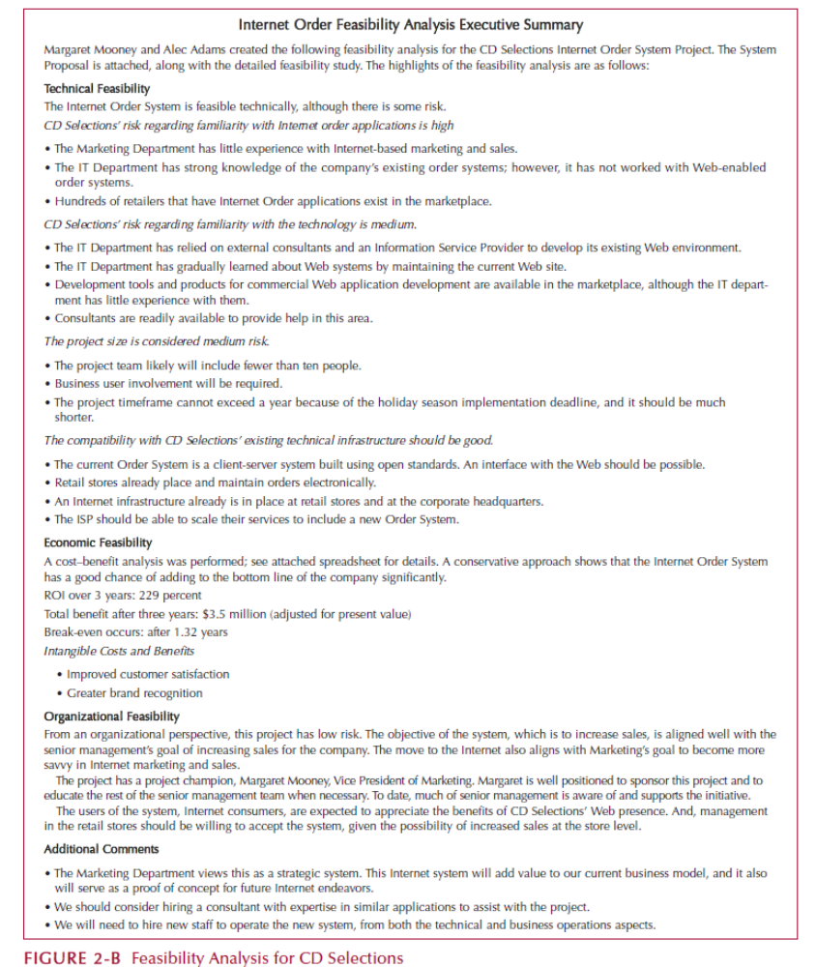

Requirements Definition Example

